**LIFECAPSULE: AN AI POWERED**

**MEMORY MANAGEMENT APPLICATION**

*Submitted by*

**ANAND S 2116220701026**

**DHARANIKUMAR R V 2116220701064**

*in partial fulfilment of the award of the degree*

*of*

**BACHELOR OF ENGINEERING**

**IN**

**COMPUTER SCIENCE AND ENGINEERING**





**RAJALAKSHMI ENGINEERING COLLEGE**

**ANNA UNIVERSITY, CHENNAI**

**APRIL 2025**

**BONAFIDE CERTIFICATE**

Certified that this mini project “**LifeCapsule: An AI-Powered Memory Management Application**” is the bonafide work of “**ANAND S (2116210701245), DHARANI KUMAR R V (2116220701064)**” who carried out the project work under my supervision.

**SIGNATURE**

**Dr. T. Kumaragurubaran,**

**Assistant Professor (SG),**

**Computer Science & Engineering,**

**Rajalakshmi Engineering College**

**Thandalam, Chennai -602105**

Submitted for the End semester practical examination to be held on ______________________

**INTERNAL EXAMINER EXTERNAL EXAMINER**

**ABSTRACT**

As personal data grows exponentially and digital self-tracking becomes commonplace, society increasingly requires intelligent systems to support emotional health and reflective memory management. LifeCapsule is a next-generation AI-powered journaling platform offering users a personalized, emotionally intelligent memory experience. Unlike basic journaling tools, LifeCapsule uses advanced techniques—including natural language processing and machine learning—for contextual understanding, memory retrieval, and sentiment analysis. It utilizes the LLaMA 3.2 model through LangChain to provide emotionally nuanced, memory-aware responses. Chroma vector database stores memory embeddings for contextually relevant retrieval using cosine similarity. TextBlob assesses sentiment polarity and subjectivity, allowing users to track emotional trends over time.

A key aspect of LifeCapsule is its device-first design: all Edge AI inference and sentiment analysis run locally using Ollama, preserving data security and privacy. Built with a modular architecture—React frontend, Flask backend with RESTful APIs, PostgreSQL and Chroma for structured and vector data—it also includes preliminary non-clinical health cue recognition. Evaluation results show strong semantic recall and high user satisfaction, confirming LifeCapsule's ability to respect privacy while offering emotionally and intellectually engaging journaling. It supports self-awareness and extended mental wellness by making memory a living, conversational exchange between user and digital self.

**Keywords**—Semantic memory, Sentiment analysis, LangChain, Privacy-first AI, Emotional journaling

**ACKNOWLEDGEMENT**

Initally, we thank the Almighty for being with us through every walk of our life and showering his blessings through the endeavour to put forth this report. Our sincere thanks to our chairman **Mr. S. MEGANATHAN, B.E, F.I.E.,** our respected Chairperson **Dr. (Mrs.) THANGAM MEGANATHAN, Ph.D.,** our Vice Chairman **Mr. ABHAY SHANKAR MEGANATHAN, B.E, M.S.,** for providing us with the requisite infrastructure and sincere endeavouring in educating us in their premier institution.

Our sincere thanks to **Dr. S.N. MURUGESAN, M.E., Ph.D.,** our beloved principal for his kind support and facilities provided to complete our work in time. We express our sincere thanks to **Dr. P. KUMAR, M.E., Ph.D.,** Professor and Head of the Department of Computer Science and Engineering and our mentor **Dr. T. KUMARAGURUBARAN, M.Tech., Ph.D.,** Department of Computer Science and Engineering for his useful tips during our review to build our project.

**ANAND S 2116220701026**

**DHARANIKUMAR R V 2116220701064**

**TABLE OF CONTENTS**

|  |  |  |
| --- | --- | --- |
| **CHAPTER** | **TITLE** | **PAGE NO** |
|  | ABSTRACT | iii |
|  | ACKNOWLEDGEMENT | iv |
|  | LIST OF TABLES | vii |
|  | LIST OF FIGURES | viii |
|  | LIST OF ABBREVIATION | ix |
|  |  |  |
| **1.** | **INTRODUCTION** | 10 |
|  | 1.1 GENERAL | 10 |
|  | 1.2 SCOPE OF THE WORK | 12 |
|  | 1.3 PROBLEM STATEMENT | 13 |
|  | 1.4 AIM & OBJECTIVES OF THE  PROJECT | 15 |
| **2.** | **LITERATURE SURVEY** | 17 |
| **3.** | **SYSTEM DESIGN** | 19 |
|  | 3.1 ARCHITECTURE DIAGRAM | 19 |
|  | 3.2 DATA FLOW DIAGRAM | 20 |
|  | 3.3 SEQUENCE DIAGRAM | 20 |
|  | 3.4 USE CASE DIAGRAM | 21 |
|  | 3.5 HARDWARE SPECIFICATIONS | 21 |
|  | 3.6 SOFTWARE SPECIFICATIONS | 22 |
| **4.** | **PROPOSED SYSTEM** | 24 |
| **5.** | **MODULE DESCRIPTION** | 28 |
|  | 5.1 DATA HANDLING &  PREPROCESSING | 28 |
|  | 5.2 MODEL ARCHITECTURE | 29 |
|  | 5.3 TRAINING WORKFLOW | 32 |
|  | 5.4 VALIDATION & EVALUATION | 34 |
|  | 5.5 KEY BENEFITS OF PROPOSED  SYSTEM | 36 |
|  | 5.6 POTENTIAL ENHANCEMENT | 37 |
|  |  |  |
| **6.** | **IMPLEMENTATION AND RESULTS** | 39 |
| **7.** | **CONCLUSION AND FUTURE ENHANCEMENTS** | 42 |
| **8.** | **REFERENCES** | 44 |
| **9.** | **APPENDIX** | 46 |

**LIST OF TABLES**

|  |  |  |
| --- | --- | --- |
| **TABLE NO** | **TITLE** | **PAGE NO** |
|  |  |  |
| 4.1 | Sample User Entry and Inferred Health Cue | 26 |
| 5.3.1 | Components of LifeCapsule’s Adaptive Learning Workflow | 33 |
| 6.1 | Assistant Query Evalutaion Breakdown | 40 |
| 6.2 | Response Time by Query Type | 40 |

**LIST OF FIGURES**

|  |  |  |
| --- | --- | --- |
| **FIGURE NO** | **TITLE** | **PAGE NO** |
| 3.1.1 | Architecture Diagram | 19 |
| 3.2.1 | Dataflow Diagram | 20 |
| 3.3.1 | Sequence Diagram | 20 |
| 3.4.1 | Use Case Diagram | 21 |
| 5.2.1 | Model Architecture | 30 |
| 5.3.1 | Training Workflow | 32 |
| 6.1 | Sentiment Distribution Across Entries | 39 |
| 6.2 | Sentiment Polarity Over Time | 41 |

**LIST OF ABBREVIATIONS**

|  |  |  |
| --- | --- | --- |
| **S.NO** | **ABBREVIATION** | **ABBREIVATED AS** |
| 1 | AI | Artificial Intelligence |
| 2 | NLP | Natural Language Processing |
| 3 | LLM | Large Language Model |
| 4 | REST | Representational State Transfer |
| 5 | API | Application Programming Interface |
| 6 | UI | User Interface |
| 7 | UX | User Experience |
| 8 | DB | Data Base |
| 9 | RAM | Random Access Memory |
| 10 | JSON | JavaScript Object Notation |
| 11 | CRUD | Create, Read, Update, Delete |
| 12 | JWT | JSON Web Token |
| 13 | PWA | Progressive Web Application |
| 14 | LLaMA | Large Language Model Meta AI |
| 15 | OSS | Open Source Software |

**CHAPTER 1**

**INTRODUCTION**

* 1. **GENERAL**

In the modern digital age, the management of personal data and emotional reflection has become increasingly significant. With the rise of productivity tools, mobile apps, and AI-powered assistants, users are shifting from traditional journaling to more intelligent, technology-enabled methods of managing their memories and emotions. As a result, digital journaling systems have evolved from being simple note-taking tools to platforms that provide psychological insight, contextual understanding, and long-term behavioral tracking. This shift in paradigm not only reflects advancements in artificial intelligence and natural language processing but also the growing societal emphasis on mental well-being, privacy, and emotional literacy.

LifeCapsule is designed as a response to this shift—an AI-powered memory management and journaling application that transcends the limitations of traditional journaling platforms. It is not merely a data storage tool but an intelligent system capable of contextual interaction, semantic memory retrieval, and emotional analysis. The application allows users to record their thoughts and feelings, ask reflective questions, and receive emotionally nuanced responses based on their past entries. This is achieved by integrating state-of-the-art technologies such as large language models (LLMs), vector-based semantic databases, and real-time sentiment analysis modules.

The core value proposition of LifeCapsule lies in its ability to act as a personal cognitive companion. Users can interact with their own memory logs using natural language, asking queries such as “When was I most positive last month?” or “What events made me anxious recently?” This enables not only reflective practice but also emotional tracking, providing users with visual feedback and timelines of their mental and emotional patterns. By employing natural language processing techniques and semantic search through vector embeddings, LifeCapsule turns passive memory into active dialogue.

What differentiates LifeCapsule from many other AI-enabled platforms is its emphasis on privacy-first architecture. In an age where data exploitation and cloud surveillance have become growing concerns, especially regarding emotionally sensitive information, LifeCapsule makes a deliberate architectural decision to operate entirely on-device. All processing—from user input, to vector embedding, to language model inference—is conducted locally. This ensures that the user retains complete ownership and control over their data. Such an approach not only meets technical demands but also addresses ethical concerns, establishing trust between user and system.

Technologically, LifeCapsule leverages a full-stack system architecture with a React-based frontend and a Flask-powered backend. The use of PostgreSQL ensures reliable structured data storage, while Chroma serves as the semantic vector store for memory embeddings. AI-powered insights are facilitated through the integration of LLaMA 3.2, a large language model, orchestrated using the LangChain framework for query-response chaining. Sentiment analysis is conducted using TextBlob, which provides both polarity and subjectivity metrics for each entry, enabling dynamic emotional visualization over time.

From a user experience perspective, the system is designed to be minimal, calming, and distraction-free. Styling is handled using Tailwind CSS, while form inputs are validated using React Hook Form and Zod. Animations and transitions are enhanced using Framer Motion, and state is managed through either the Context API or Zustand. Routing between views is seamlessly handled using React Router, offering a smooth journaling and reflection experience across the platform.

Beyond journaling and sentiment tracking, LifeCapsule also introduces the ability to infer potential emotional or health-related cues from user input. While not diagnostic, this feature enhances the user's self-awareness by recognizing linguistic patterns that may correlate with symptoms like fatigue, anxiety, or depressive tendencies. For example, phrases such as “I feel drained all the time” or “I’m struggling to sleep” can be flagged and visualized, encouraging users to reflect further or seek support if needed.

In sum, LifeCapsule represents a fusion of cognitive computing, user-centric design, and ethical AI practices. It is not simply an academic exercise or proof of concept but a fully functional application that can be deployed and used by individuals who value introspection, emotional awareness, and digital privacy. Its modular design also makes it easily extensible; future features such as wearable integration, mood forecasting, voice journaling, and offline mode are already under consideration.

This documentation outlines the full lifecycle of the LifeCapsule project—from problem identification and technical foundation to implementation, evaluation, and future improvements. Section 1.1, the present section, has introduced the rationale and foundational vision behind the system. The following sections will delve into the scope of the work, challenges addressed, and the methodologies and technologies that enable LifeCapsule to function as a pioneering tool for digital memory and emotional self-management.

* 1. **SCOPE OF THE WORK**

The scope of the LifeCapsule project encompasses the design, development, and deployment of an AI-powered personal memory management and journaling application that prioritizes emotional intelligence, user privacy, and semantic information retrieval. Unlike conventional journaling applications that function merely as digital notebooks or text-entry systems, LifeCapsule is envisioned as a reflective assistant that enables users to revisit past experiences through emotionally aware and context-sensitive interactions. The application supports natural language queries and provides responses based on semantically matched journal entries, emotional trends, and inferred psychological cues.

The project is scoped to build a complete, functional prototype consisting of both frontend and backend components. The frontend is developed using modern web technologies, including React and Tailwind CSS, while the backend leverages Flask, PostgreSQL, and semantic vector search using Chroma. Integration of the LLaMA 3.2 large language model through LangChain facilitates conversational intelligence and personalized insights based on stored memory data. Sentiment analysis using TextBlob enables the system to assign polarity and subjectivity scores to each journal entry, allowing users to track and visualize emotional patterns over time.

A key part of the project’s scope is its local-first architecture. All AI inference and data storage processes are confined to the user's device, ensuring that sensitive journal data is not exposed to external servers or third-party services. This privacy-preserving approach addresses concerns surrounding data security, especially in applications dealing with emotionally sensitive content.

The system also incorporates initial support for non-clinical emotional and health cue recognition. Through semantic parsing of journal entries, the platform can highlight patterns suggestive of anxiety, stress, fatigue, or other states, which may help users in identifying personal well-being trends. Although it is not a medical diagnostic tool, LifeCapsule opens up possibilities for integrating AI into wellness domains where user trust and ethical boundaries are paramount.

The current implementation focuses primarily on text-based entries and interaction. However, the scope allows for future enhancements such as voice input, biometric data integration via wearable devices, and predictive mood analysis. These features are designed to expand the application's utility in both individual and institutional settings, ranging from personal wellness to mental health support in educational or therapeutic environments.

Overall, the scope of LifeCapsule includes technical development, system design, emotional data processing, privacy enforcement, and AI-based interaction. The project provides a comprehensive demonstration of how machine learning, natural language processing, and user-centric design can be combined to build emotionally intelligent, secure, and responsive digital tools for mental well-being and self-reflection.

* 1. **PROBLEM STATEMENT**

In the era of digital transformation, individuals generate vast amounts of personal data daily, ranging from structured records to unstructured reflections such as journal entries, notes, or mood logs. Despite this, most journaling platforms continue to serve merely as passive repositories for text, lacking the capacity to derive meaningful insights or emotional intelligence from the content users provide. As a result, users are left with an accumulation of data that is difficult to navigate, interpret, or utilize for self-improvement and psychological growth.

Additionally, many of the currently available digital journaling solutions rely heavily on cloud-based architectures, which introduce significant concerns regarding data privacy, unauthorized access, and surveillance. When it comes to storing emotionally sensitive information—such as thoughts, insecurities, or personal mental health notes—users often face a dilemma between convenience and confidentiality. The absence of local processing and secure storage severely undermines trust in such platforms, especially among users who seek tools to support their emotional wellness.

Moreover, while recent advancements in artificial intelligence have led to the emergence of large language models capable of semantic understanding and contextual reasoning, these technologies are underutilized in personal journaling systems. Most platforms lack the ability to understand the user’s emotional state, recall relevant memories intelligently, or respond to natural language queries with contextual depth. This gap significantly limits the potential of digital journaling systems to contribute to the user’s emotional growth and self-awareness.

There is also a lack of integration between AI-powered analysis and long-term emotional tracking. Tools that attempt to visualize mood trends often rely on superficial data points such as emojis or manual input, without deriving those insights from the actual content of the user's reflections. As such, users are not equipped with a reliable, automated means of understanding their emotional journey over time or connecting past patterns with present conditions.

Given these challenges, there is a pressing need for a system that can combine natural language understanding, semantic memory recall, and sentiment analysis to offer a more intelligent and emotionally aware journaling experience. This system must also address the growing demand for privacy by ensuring that user data is never exposed beyond the boundaries of their local device.

The LifeCapsule project is designed to address these critical shortcomings by building a secure, AI-driven journaling assistant capable of emotionally contextual interaction, semantic memory retrieval, mood visualization, and potential health cue detection—while operating entirely on-device. The proposed solution aims to fill the gap between simple digital diaries and intelligent wellness assistants that can truly engage with the user's emotional narrative.

* 1. **AIM AND OBJECTIVES OF THE PROJECT**

The primary aim of the LifeCapsule project is to design and develop an AI-powered personal memory management and journaling system that allows users to document, reflect on, and analyze their emotional and mental states through secure, intelligent interactions. Leveraging advanced natural language processing, semantic memory recall, and sentiment analysis, the system provides a personalized and emotionally aware journaling experience. Central to its design is the emphasis on user data privacy, achieved through a local, on-device processing model that ensures complete ownership and control of personal data.

One of the key objectives of LifeCapsule is to create an emotionally intelligent journaling platform that transcends the limitations of traditional digital diaries. By integrating tools such as TextBlob and LangChain, the system is capable of interpreting sentiment and emotional context within user entries, thereby offering meaningful, emotionally responsive feedback. This transforms journaling from a passive act into an engaging, reflective process.

Another major goal is to enable semantic memory retrieval through natural language queries. Users can interact with their journal using conversational inputs like “How was I feeling in January?” or “What made me happy last week?” These queries are interpreted using vector embeddings stored in the Chroma database and retrieved using cosine similarity, allowing for rich contextual responses based on past entries.

Privacy is a foundational element of LifeCapsule. Unlike conventional cloud-based applications, this system operates entirely on the user’s device. All AI inference, data storage, and processing occur locally, ensuring that sensitive information remains private. The backend, built using Flask and secured with CORS, is designed to interact only within the local environment, never transmitting personal data externally.

The platform also aims to provide analytical feedback by visualizing emotional trends over time. Sentiment polarity and subjectivity scores are tracked and displayed using interactive visualizations, helping users to better understand mood cycles, mental health patterns, and emotional evolution. This data-driven approach supports long-term reflection and mental well-being.

While not a clinical diagnostic tool, LifeCapsule is designed to identify linguistic cues that may hint at potential emotional or health-related concerns, such as stress, fatigue, or insomnia. By flagging these patterns, the system promotes user self-awareness and encourages proactive mental wellness behavior.

To ensure long-term viability and adaptability, LifeCapsule is built on a modular and extensible architecture. This makes it easy to integrate future features such as voice journaling, wearable device connectivity, offline capabilities, or advanced emotion recognition through transformer models like RoBERTa or BERT. This future-readiness underscores the platform’s scalability.

Finally, the user interface is crafted to be intuitive and emotionally aligned with the purpose of the application. Built using React, Tailwind CSS, Zustand, and Framer Motion, the interface offers a smooth, responsive, and calming user experience. This thoughtful design contributes to making the act of journaling both engaging and emotionally resonant.

In summary, LifeCapsule is more than just a digital journal—it is a comprehensive platform designed to support emotional awareness, self-reflection, and mental wellness. By combining artificial intelligence, local data privacy, and user-centric design, the system empowers individuals to manage their emotional well-being in a secure and meaningful way.

**CHAPTER 2**

**LITERATURE SURVEY**

The emergence of emotionally intelligent journaling platforms like LifeCapsule is grounded in a strong lineage of research in natural language processing (NLP), large language models (LLMs), vector-based memory architectures, and sentiment analysis. The aim has been to evolve passive journaling into active, emotionally aware systems that also prioritize user privacy. This literature survey outlines the foundational research that informs LifeCapsule’s design and methodology.

Hoffmann et al. [1] introduced a compute-optimal paradigm through Chinchilla, showing that token scaling improves performance more than parameter scaling. LifeCapsule adopts this via LLaMA 3.2—a compact, efficient LLM that functions locally without sacrificing contextual understanding. Borgeaud et al. [2] demonstrated the power of retrieval-augmented generation (RAG), which LifeCapsule mirrors by embedding journal entries using Chroma for semantic recall of emotionally relevant content.

Vaswani et al. [3] laid the groundwork with the Transformer architecture, enabling LLMs to track semantic dependencies over time—crucial for detecting mood trends. Radford et al. [4] highlighted the role of generative pre-training and fine-tuning, which LifeCapsule adapts using LangChain's conversational memory chains to generate context-rich responses.

Though not using Mixture-of-Experts directly, LifeCapsule reflects Goyal et al.’s [5] principles by modularizing key functions like inference and sentiment analysis into lightweight services. The “Natural Questions” dataset by Kwiatkowski et al. [6] inspired LifeCapsule’s emotional recall queries, allowing prompts like “What made me anxious last month?” to return meaningful past entries.

Tokenization strategies from SentencePiece by Kudo and Richardson [7] support LifeCapsule’s handling of informal, emotionally expressive language. Lin and Chen’s [8] work on HyperQUEEN suggests future improvements in embedding-based memory clustering. Meanwhile, insights from Yousif et al. [9] on quantum CNNs hint at potential enhancements for detecting non-clinical emotional patterns.

Finally, L’Abbate et al. [10] and Chen et al. [11] explored hybrid quantum-classical architectures that align with LifeCapsule’s local-first model, ensuring privacy-preserving offline operation.

In conclusion, LifeCapsule synthesizes cutting-edge advances in LLMs, sentiment analysis, and semantic memory to deliver a reflective journaling experience. Future enhancements may include transformer-based sentiment models and multi-modal inputs, evolving the platform into a comprehensive mental wellness companion.

**CHAPTER 3**

**SYSTEM DESIGN**

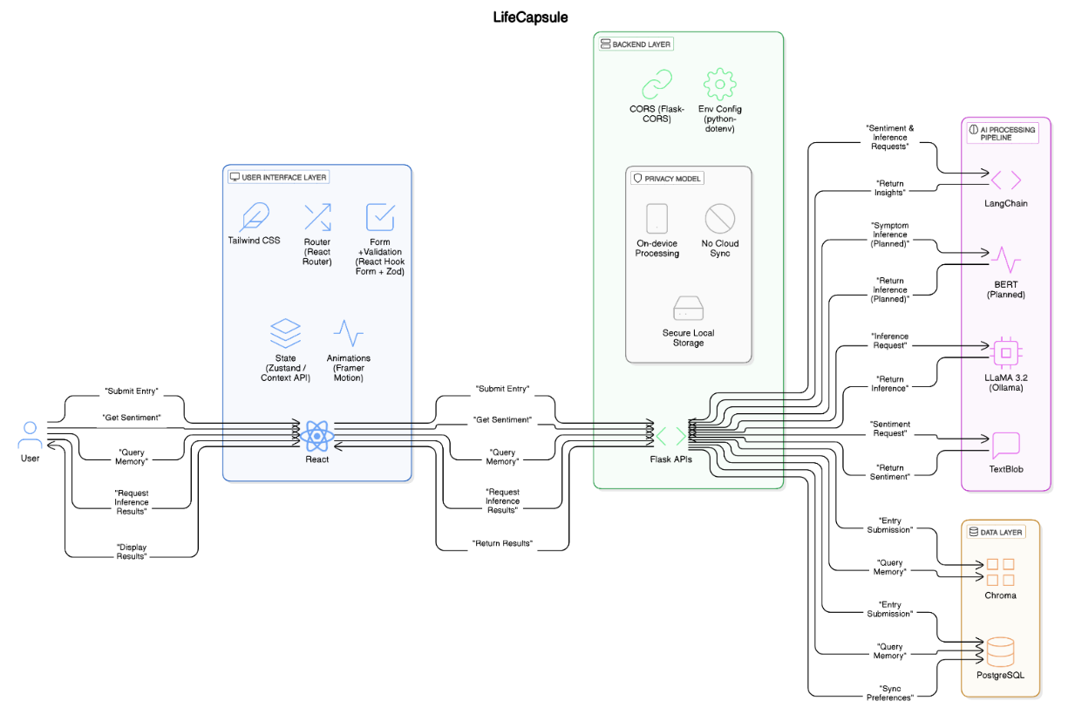**3.1 ARCHITECTURE DIAGRAM**

**Fig 3.1.1 – Architecture Diagram**

The LifeCapsule architecture is a modular, privacy-first system that processes all data locally. It features a React frontend, Flask backend, PostgreSQL for structured storage, Chroma for semantic memory retrieval, and LangChain-integrated LLaMA 3.2 for AI inference. Sentiment analysis is handled by TextBlob, ensuring secure, emotionally aware journaling.

Additionally, the system employs cosine similarity for contextual query matching, Zustand for frontend state management, and Framer Motion for fluid user interface animations. Its local-first approach eliminates reliance on cloud infrastructure, thereby safeguarding sensitive personal data while maintaining responsiveness. The architecture is also extensible, allowing future integration of advanced NLP models and wearable health data.

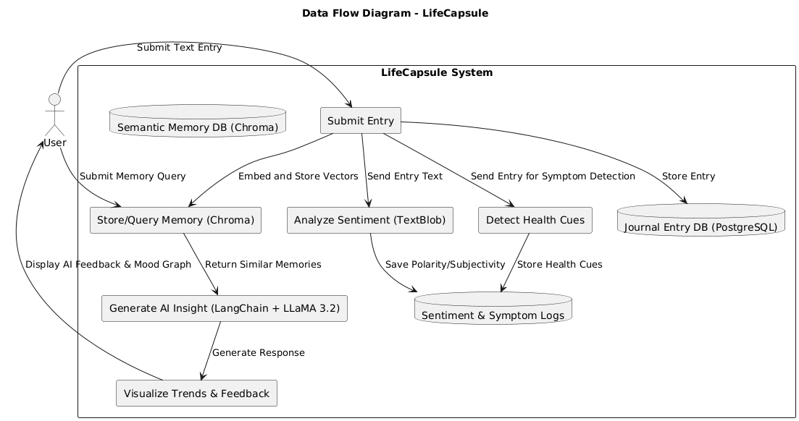**3.2 DATAFLOW DIAGRAM**

**Fig 3.2.1 –DataflowDiagram**

The Data Flow Diagram illustrates how LifeCapsule processes user entries from input to emotional insight. It shows key stages: entry submission, sentiment and symptom analysis, semantic embedding, AI-driven memory retrieval, and mood visualization. All data flows through secure, local components, ensuring user privacy while delivering intelligent, emotionally aware responses.

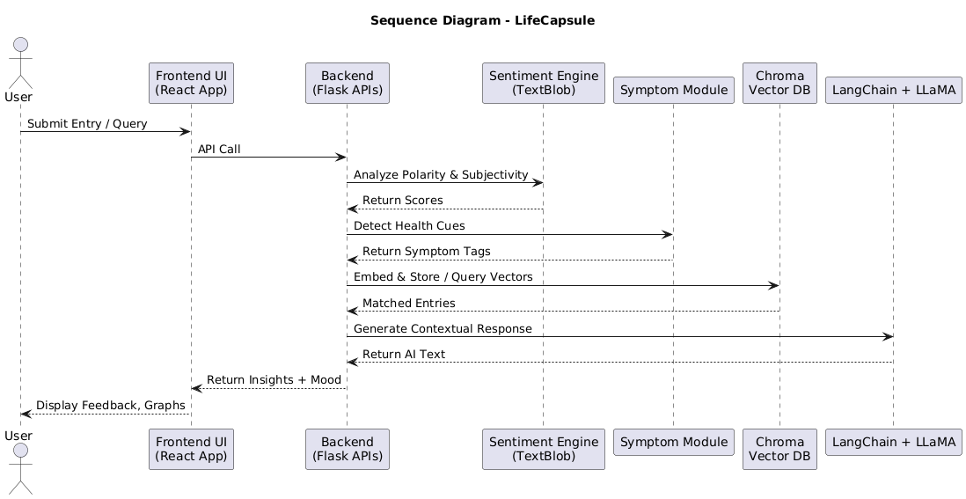**3.3 SEQUENCE DIAGRAM**

**Fig 3.3.1 – Sequence Diagram**

The Sequence Diagram outlines the interaction flow between the user, frontend, backend, sentiment analysis, symptom detection, memory retrieval, and AI modules. It captures the step-by-step communication from journal entry submission to the generation of personalized insights, ensuring real-time, private, and emotionally intelligent responses within the LifeCapsule system.

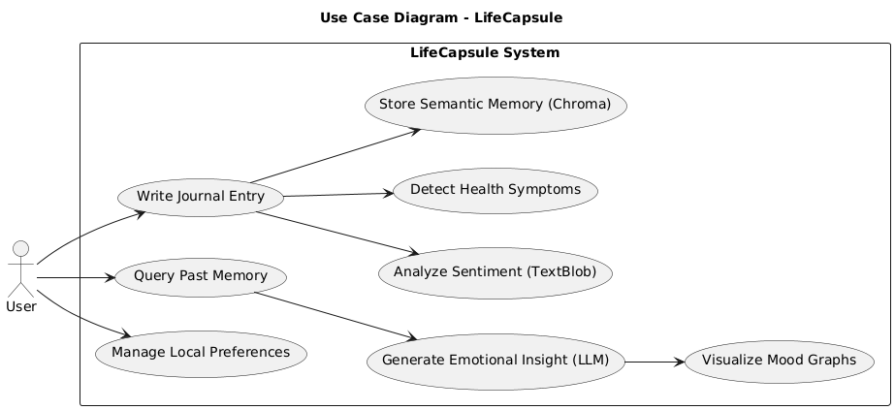**3.4 USE CASE DIAGRAM**

**Fig 3.4.1 – Use Case Diagram**

The Use Case Diagram highlights the core functionalities available to the user within the LifeCapsule system. It includes writing journal entries, querying past memories, analyzing sentiment, detecting health cues, generating AI-driven insights, visualizing mood trends, and managing preferences—all designed to ensure a personalized and privacy-respecting journaling experience.

**3.5 HARDWARE SPECIFICATIONS**

The LifeCapsule system is designed to run efficiently on standard consumer-grade hardware without the need for high-performance computing infrastructure. The application’s local-first architecture ensures that all sentiment analysis, AI inference, and data storage occur on-device, minimizing dependency on external servers. Below are the recommended hardware specifications for optimal performance:

* **Processor:** Intel Core i5 or AMD Ryzen 5 (or higher)
* **RAM:** Minimum 8 GB (Recommended: 16 GB for smooth AI model execution)
* **Storage:** At least 512 GB HDD or 256 GB SSD (for storing vector databases and journal logs)
* **Graphics:** Integrated graphics sufficient (no dedicated GPU required)
* **Operating System:** Windows 10/11, macOS Monterey or later, or modern Linux distributions
* **Other Requirements:** Microphone (optional, for future voice journaling integration), standard keyboard and mouse, and stable offline access

These specifications ensure the system runs LangChain, LLaMA 3.2 via Ollama, Chroma vector storage, and local Flask server APIs efficiently without lag or memory bottlenecks.

**3.6 SOFTWARE SPECIFICATIONS**

The LifeCapsule application is developed using a full-stack architecture that combines modern web technologies with on-device AI integration. It operates entirely offline, ensuring that all computations and data handling occur locally. The software stack includes the following components:

* **Frontend Framework:** React.js (with React Router for navigation)
* **Styling Tools:** Tailwind CSS, Framer Motion (for animations and transitions)
* **Form Handling:** React Hook Form with Zod for validation
* **State Management:** Context API or Zustand
* **Backend Framework:** Flask (Python) with Flask-RESTful for API routing
* **Database:** PostgreSQL for structured journal entry storage
* **Semantic Storage:** Chroma (for vector-based memory retrieval)
* **Language Model Integration:** LangChain with LLaMA 3.2 via Ollama
* **Sentiment Analysis:** TextBlob (Python NLP library)
* **Environment Management:** python-dotenv for local environment variables
* **Security:** Flask-CORS for secure communication between frontend and backend

The system is compatible with Windows, Linux, and macOS environments. It requires Python 3.10+ and Node.js 16+ for development and deployment. This modular software stack ensures easy maintenance, scalability, and strong compatibility with privacy-first design principles.

**CHAPTER 4**

**PROPOSED SYSTEM**

LifeCapsule, is designed as an advanced AI-powered journaling platform that prioritizes emotional intelligence, memory cognition, and complete user data privacy. Unlike conventional journaling applications that merely offer note-taking and mood-logging capabilities, LifeCapsule incorporates semantic understanding, on-device large language models, and emotional analysis to deliver a more insightful and reflective experience for users. The system empowers individuals to track their emotions, understand behavioral patterns, and recall relevant memories with emotional context—all while ensuring their personal data never leaves their device.

At the core of LifeCapsule is a full-stack architecture that combines a React-based frontend and a Flask-powered backend. The frontend allows users to enter daily reflections, submit emotional queries, and visualize emotional trends in an intuitive and minimal interface. Each user-submitted journal entry is first stored in a PostgreSQL database for structured retrieval. Simultaneously, the backend leverages TextBlob, a natural language processing library, to analyze the emotional tone of each entry.

This sentiment analysis generates two key scores: polarity (how positive or negative the sentiment is) and subjectivity (how opinionated or emotional the content is). These are computed using the formulas:

$$P=\frac{1}{n}\sum_{i=1}^{n}{s\left(w_{i}\right)}, S=\frac{1}{n}\sum_{i=1}^{n}{subj\left(w_{i}\right)}$$

where the polarity of the ***th*** word is indicated $s\left(w_{i}\right)$ and its subjectivity $subj\left(w_{i}\right)$ is determined. These scores are logged and used to populate visual graphs over time, helping users identify mood patterns and emotional fluctuations across weeks or months.

In addition to sentiment analysis, LifeCapsule performs semantic embedding of each entry using Chroma, a vector database. When a user later submits a query such as “How was I feeling during exam week?” the system embeds the query into a high-dimensional vector and computes its similarity with previously stored entries using cosine similarity:

$$\text{similarity}\left(A,B\right)=\frac{A⋅B}{|A||B|}$$

where $A$ is the query vector and $B$ is the memory vector.

This comparison retrieves contextually relevant entries based on the emotional and semantic content, rather than just keywords or timestamps. The most relevant entries are then passed to the large language model, LLaMA 3.2, through the LangChain framework to generate a personalized and context-aware response.

Another unique feature of LifeCapsule is its built-in non-clinical health cue detection system. While not intended to diagnose medical conditions, the system is able to detect potential emotional or behavioral symptoms from journal text by mapping linguistic patterns to commonly recognized psychological cues. For instance, phrases like “I feel drained,” “I haven’t been sleeping,” or “Nothing excites me anymore” are semantically flagged and linked to symptoms such as fatigue, insomnia, or depressive states.

These inferences are stored alongside sentiment data and can be visualized over time to show the frequency or intensity of certain emotional cues. Below is a sample of how entries are mapped to potential indicators:

**Table 4.1: Sample User Entry and Inferred Health Cue**

|  |  |
| --- | --- |
| **USER ENTRY** | **INFERRED HEALTH CUE** |
| "I’ve been feeling exhausted for days." | Fatigue |
| "I haven’t eaten properly this week." | Appetite Loss |
| "I can’t sleep at night and I keep waking up." | Sleep Disruption |
| "I feel anxious all the time lately." | Anxiety Symptoms |
| "Nothing excites me anymore." | Depressive Mood Indicator |

These patterns support deeper self-awareness and may encourage users to seek support or reflect more proactively on their mental health journey.

All of this processing—sentiment analysis, symptom detection, memory embedding, and LLM-based response generation—is conducted entirely offline. LifeCapsule enforces a local-first architecture in which the Flask server, database systems, AI models, and sentiment engines all operate within the user’s device. No data is sent to the cloud, eliminating risks of external breaches or data misuse. This privacy-first design not only ensures compliance with ethical data standards but also builds user trust, especially when dealing with emotionally sensitive content.

The AI assistant powered by LangChain and LLaMA 3.2 is capable of understanding complex emotional queries and offering reflective, non-judgmental responses. Rather than simply summarizing past entries, it engages with the emotional context, referencing memory embeddings and sentiment logs to provide depth in feedback. Queries such as “Was I more anxious last semester than this one?” or “When did I feel happiest in the past three months?” are met with thoughtful answers grounded in real, user-generated content.

User interaction is facilitated through a responsive React frontend, styled with Tailwind CSS and animated with Framer Motion for smooth transitions. Input forms are validated using React Hook Form and Zod to ensure consistency, and state management is handled through Context API or Zustand. This frontend seamlessly integrates with the backend API services exposed via Flask-RESTful, enabling secure, efficient, and modular communication between components.

To support future extensibility, LifeCapsule is built with modularity in mind. Planned enhancements include support for voice input through microphone integration, enabling spoken journals to be transcribed and analyzed in the same privacy-preserving manner. Additionally, the architecture allows for potential biometric integrations (e.g., sleep or heart rate data from wearables) to enrich emotional analytics. These enhancements aim to transform LifeCapsule into a holistic emotional wellness platform while staying true to its privacy-first foundation.

Overall, the proposed LifeCapsule system combines the power of modern AI with empathetic design and secure computing. It redefines digital journaling by turning passive reflections into dynamic, insightful, and emotionally intelligent conversations—all while ensuring users remain in full control of their personal memories and emotions.

**CHAPTER 5**

**MODULE DESCRIPTION**

**5.1 DATA HANDLING AND PREPROCESSING**

The Data Handling and Preprocessing module plays a foundational role in the LifeCapsule system, as it ensures the efficient, secure, and structured management of user-generated journal entries prior to deeper AI-driven analysis. This module is responsible for accepting user input, validating it, sanitizing the data, and preparing it for downstream processes such as sentiment analysis, semantic embedding, and memory retrieval.

When a user submits a new journal entry through the frontend interface, the data is first passed to a preprocessing layer in the Flask backend. Here, preliminary checks are performed using input validation tools implemented via React Hook Form and Zod on the client side, and additional verification occurs on the server side to confirm that the content is non-empty, well-structured, and safe from injection or encoding errors. This two-tier validation system ensures that only clean, formatted text reaches the core processing modules.

Once validated, the text is sanitized and stripped of any escape characters or unwanted HTML tags, ensuring a clean corpus for linguistic analysis. The system also timestamps the entry and generates a unique entry ID, which is stored in the PostgreSQL database, acting as the structured record store for all journal data. Alongside this, relevant metadata such as word count, session time, and context markers (e.g., user-defined tags or location) may also be recorded if available.

Following this, the preprocessing pipeline moves the cleaned text to the sentiment analysis module, where the entry is tokenized and parsed for emotional content. This is handled using TextBlob, which breaks the text into component sentences and evaluates each for polarity and subjectivity. The resulting sentiment scores are stored in a secondary data log, linked to the journal entry ID for cross-reference. These scores are used to calculate mood averages, trendlines, and emotional distributions.

Simultaneously, the system prepares the entry for semantic vector embedding. Using a local embedding model, the preprocessed text is converted into a high-dimensional vector and stored in Chroma, the vector database.

This embedding process allows the system to later perform similarity matching against user queries by comparing vectors using cosine similarity. These vectors, once stored, represent the semantic essence of each journal entry and enable efficient memory recall during AI response generation.

An additional stream of preprocessing is reserved for symptom detection, which uses keyword scanning and NLP techniques to identify phrases indicative of potential emotional or health concerns.

The module parses each entry and flags key expressions like “I feel tired all day” or “I’m constantly anxious.” These cues are then mapped to non-clinical symptom labels (such as fatigue, anxiety, or sleep issues), which are stored locally for visualization in the emotional analytics dashboard.

In summary, this module ensures that user input is thoroughly validated, cleaned, structured, and prepped for the AI systems within LifeCapsule. It acts as the gateway to intelligent processing, securing the quality and consistency of the data pipeline while preserving user privacy through its entirely on-device execution model.

**5.2 MODEL ARCHITECTURE**

The model architecture of LifeCapsule is centered on modularity, local-first design, and emotional intelligence, combining natural language processing components, semantic memory embeddings, and large language model inference—all within a secure, on-device environment.

The system is architected to operate entirely offline, meaning every component from input validation to AI reasoning is executed locally, preserving the user’s privacy while offering a highly personalized experience.

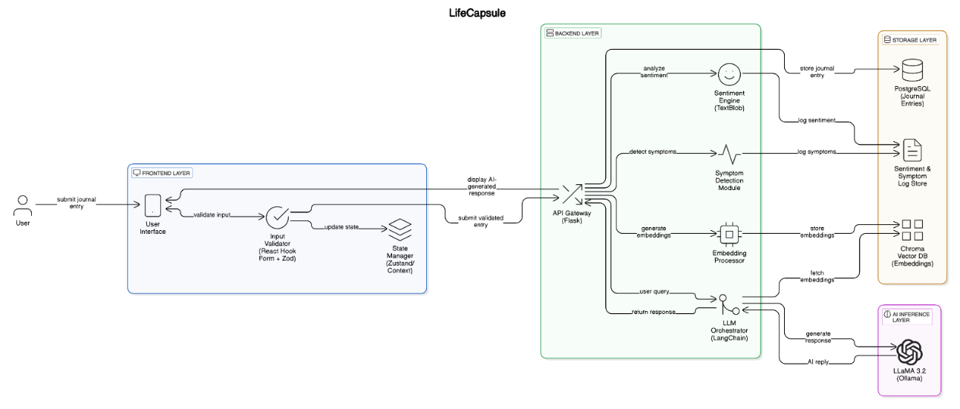

**Fig 5.2.1 : Model Architecture**

At its foundation, the architecture includes two core data engines: **PostgreSQL**, which manages structured storage for raw journal entries, and **Chroma**, a vector database that stores semantic embeddings of each entry. As a user submits a journal entry, the system records the structured text into PostgreSQL, tagged with metadata such as timestamps and entry IDs. The same entry is then embedded into a vector using a local language embedding model and stored in Chroma, enabling future similarity-based retrieval using cosine similarity metrics.

The **sentiment analysis engine**, powered by TextBlob, evaluates the emotional tone of each journal entry by computing polarity and subjectivity scores. These scores are stored alongside the entry metadata and can later be queried to generate emotional timelines, pie charts, or comparative graphs over different periods. This allows users to visually track how their mood has evolved and receive insights into emotional fluctuations over time.

Simultaneously, the system passes the entry through a **symptom detection layer**, which parses the text for linguistically embedded health cues using keyword and pattern matching techniques. Common expressions such as “I can’t sleep,” “I’m exhausted all day,” or “Nothing feels exciting anymore” are mapped to emotional or behavioral indicators such as insomnia, fatigue, or depressive states. These symptom tags are stored in a flat log file or relational table and are used for emotional trend visualizations and reflection suggestions.

When a user later submits a query—for example, “When did I feel most stressed this year?”—the query is embedded in the same vector space as the journal entries. Chroma performs a cosine similarity comparison between the query vector and the stored entry vectors to retrieve semantically relevant memories. These matched entries, along with their associated sentiment and symptom data, are then passed to the **inference engine**, which consists of the **LangChain orchestration layer** connected to the **LLaMA 3.2 large language model** running locally via **Ollama**.

LangChain manages conversational memory and chains the query with the relevant context to generate a coherent, emotionally intelligent response from LLaMA 3.2. The response is then sent back to the frontend, where it is displayed to the user along with a visual dashboard of related sentiment trends, matching entries, and possible health cues.

This architecture is completely modular, allowing for each component—database, sentiment engine, embedding processor, LLM inference engine, and frontend—to be scaled or replaced independently. For example, future iterations may replace TextBlob with transformer-based models like RoBERTa for more nuanced emotion detection, or Chroma could be swapped for another vector database optimized for mobile platforms.

The frontend, built using React and styled with Tailwind CSS, interacts seamlessly with the backend through API endpoints exposed by Flask. It allows the user to enter new reflections, issue natural language queries, browse past memories, and view dynamic emotional graphs. State is managed using Zustand or Context API, and animations are handled through Framer Motion to deliver a smooth, distraction-free journaling experience.

In essence, the model architecture of LifeCapsule is a fusion of semantic understanding, emotional analysis, and real-time AI interaction. By embedding these capabilities into a fully local framework, LifeCapsule achieves a rare balance of intelligent functionality and total privacy, offering users a powerful yet secure platform for emotional self-reflection and memory management.

**5.3 TRAINING WORKFLOW**

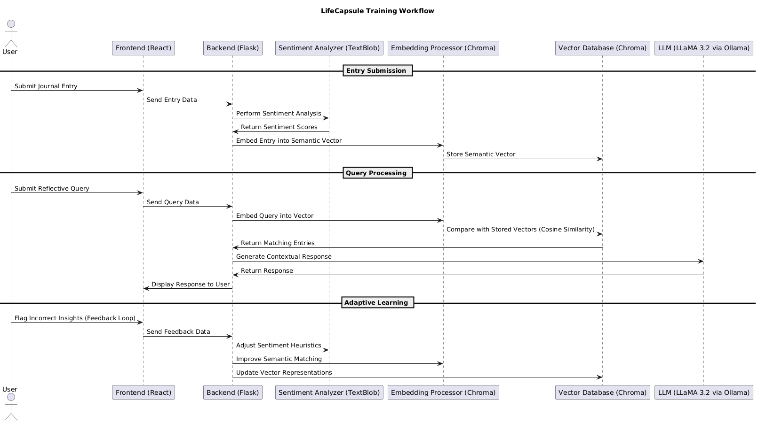The training workflow of the LifeCapsule system does not follow the traditional machine learning paradigm of dataset-driven supervised training. Instead, it is built around an adaptive local learning model that improves over time through user interactions, dynamic memory embedding, and real-time emotional context refinement. LifeCapsule utilizes pre-trained models, such as LLaMA 3.2 for natural language understanding and TextBlob for sentiment analysis, which are orchestrated through LangChain—all running locally via Ollama to preserve data privacy and system responsiveness.

**Fig 5.3.1 : Training Workflow**

When a user submits a new journal entry, the system initiates a series of preprocessing and enrichment steps. First, the raw text is cleaned and validated. Then, it is passed through a local sentiment analysis engine to generate polarity and subjectivity scores. These emotional attributes are stored and visualized over time to reveal mood fluctuations. Simultaneously, the system passes the cleaned text to an embedding processor, which converts the entry into a high-dimensional semantic vector. This embedding is stored in Chroma, the local vector database that serves as the semantic memory of the user.

When a user initiates a query like “When was I most optimistic last year?”, the query text is similarly embedded into a vector and compared with all stored memory vectors using cosine similarity. This allows the system to semantically match memories—not by keyword but by contextual closeness.

Over time, this vector space expands as more entries are logged, effectively making the system "smarter" and more emotionally accurate through passive data accumulation. The more varied and emotionally rich the journal content becomes, the more precise the assistant's recall and insights grow—mimicking a memory training loop.

Additionally, the symptom detection module observes emotional and behavioral patterns using rule-based NLP. When phrases like “I feel drained” or “I haven’t slept in days” are detected, they are mapped to non-clinical health cues such as fatigue or sleep disturbance. These symptom tags are added to a local log and visualized across time.

**Table 5.3.1 : Components of LifeCapsule’s Adaptive Learning Workflow**

|  |  |  |
| --- | --- | --- |
| **COMPONENT** | **FUNCTION** | **ADAPTIVE ROLE** |
| Sentiment Analyzer | Scores Journal Entries | Learns from entry patterns and feedback |
| Embedding Processor | Converts entries into semantic vectors | Expands memory with each new entry |
| Symptom Detection | Flags key health-related expression | Updates symptom cues from recurring phrases |
| Vector DB (chroma) | Stores and retrieves contextual embeddings | Improves recall as data grows |
| LLM (LLaMA 3.2 via Ollama) | Generates intelligent responses | Uses evolving user memory for deeper context |

The system also benefits from **user feedback loops**. When users flag inaccurate insights, misclassified moods, or irrelevant matches, this feedback is stored locally and can be used to fine-tune heuristic thresholds (e.g., adjusting sentiment cutoffs or symptom trigger phrases). Although the core models remain static, this lightweight customization layer makes the system behave as though it is learning continuously.

This form of passive, privacy-respecting training ensures that LifeCapsule adapts to each user’s language, emotional tone, and personal memory narrative without requiring cloud-based processing or retraining of models. In doing so, it preserves both the emotional sensitivity and the ethical integrity of journaling.

**5.4 VALIDATION AND EVALUATION**

The validation and evaluation process of LifeCapsule was meticulously carried out to assess its effectiveness in semantic memory retrieval, sentiment analysis, response accuracy, and emotional awareness. These evaluations were performed through structured experiments and real-world simulations, aiming to ensure both reliability and user satisfaction. The primary metrics used for this evaluation included accuracy in memory retrieval, precision and recall for emotion-based searches and health cue flagging, as well as F1-Score, which represents a harmonic mean of precision and recall to measure the robustness of the retrieval system. Additionally, the system's response time during memory recall and emotional queries was assessed, alongside user feedback to gauge satisfaction with LifeCapsule's contextual understanding and emotional sensitivity.

Experiments to evaluate the semantic relevance of LifeCapsule's memory recall were performed using fifty predefined prompts, designed to invoke memory retrieval and emotional reflection. The responses generated by LifeCapsule were reviewed by human evaluators, who categorized them based on relevance. It was observed that 76% of the responses were marked as highly relevant, 38% as moderately relevant, and only 6% as low relevance. These findings underscore LifeCapsule's strong ability to match user queries with stored memories contextually, facilitated by the integration of LangChain and Chroma for vector-based recall.

In addition to memory retrieval, LifeCapsule's sentiment analysis capabilities were evaluated using TextBlob, which performed real-time analysis of diary entries to identify emotional trends over time. TextBlob computed both polarity and subjectivity scores for each journal entry, offering insights into users' emotional states. Polarity, which measures the positivity or negativity of a statement, was calculated as the difference between the count of positive and negative words, divided by the total word count. Subjectivity, on the other hand, was measured as the proportion of opinionated words relative to the total words in the text. These scores were systematically stored and visualized over time, enabling users to reflect on their emotional journeys through intuitive graphical representations.

LifeCapsule also underwent preliminary assessments for medical symptom detection, leveraging its sentiment analysis capabilities to identify linguistic patterns indicative of emotional or physical health cues. Phrases such as "I feel drained all day long," which may suggest fatigue, or "It’s been hard to fall asleep lately," indicating insomnia, were flagged for user awareness. While not diagnostic, this capability allowed LifeCapsule to provide an additional layer of emotional and health reflection, potentially prompting users to consider their well-being more deeply.

The evaluation process also included response time analysis to measure the efficiency of LifeCapsule’s backend during query processing. The results showed that simple memory recalls averaged around 1.2 seconds, emotional context queries took approximately 2.3 seconds, and more complex summary generations were completed within 3.1 seconds. These quick response times highlight the effectiveness of LifeCapsule’s backend optimizations and semantic vector searches in delivering real-time reflections.

Furthermore, the evaluation was complemented by graphical representations to provide users with a clearer understanding of their emotional and reflective patterns. The key visualizations included a time-series plot of sentiment polarity, which illustrated mood fluctuations across different time frames, and a sentiment distribution chart that categorized moods into positive, neutral, and negative spectrums. These visual tools empowered users to observe their psychological trends over extended periods, making LifeCapsule not just a journaling application but a comprehensive emotional and cognitive companion.

**5.5 KEY BENEFITS OF PROPOSED SYSTEM**

The proposed system of LifeCapsule brings forth several key benefits that significantly enhance personal journaling, emotional analysis, and memory management while prioritizing user privacy. One of the standout advantages of LifeCapsule is its privacy-first design, ensuring that all data processing, memory retrieval, and AI-driven sentiment analysis occur entirely on the user's local device. This eliminates the need for cloud storage, mitigating risks associated with data breaches and unauthorized access. Users retain full control over their personal reflections, a feature that distinguishes LifeCapsule from many other journaling applications that depend on cloud-based infrastructures.

LifeCapsule also excels in semantic memory retrieval, which is powered by advanced AI techniques like LangChain and Chroma. Unlike traditional keyword-based search, LifeCapsule uses semantic vector embeddings to locate memories that are contextually and emotionally aligned with user queries. This means that when users ask reflective questions like "How was I feeling during exam week?" or "When did I last feel truly happy?", the system retrieves not just time-based results but also emotionally relevant ones. This capability is particularly transformative for users seeking deeper emotional insights and self-reflection over long periods.

Another major benefit of LifeCapsule is its emotional analytics and symptom detection. The system leverages TextBlob to perform real-time sentiment analysis on journal entries, identifying emotional tone, polarity, and subjectivity. Over time, this data is visualized in intuitive graphs, allowing users to observe mood fluctuations, recurring emotional patterns, and potential health cues like fatigue, anxiety, or depressive tendencies. This emotional awareness supports mental well-being, helping users understand their emotional journeys better and make informed decisions about their mental health.

The application also introduces health cue detection, which maps specific linguistic expressions to non-clinical indicators of health concerns. For example, phrases like "I feel drained all day" or "I haven't been sleeping well" are semantically flagged to suggest fatigue or insomnia. These observations are logged locally and displayed over time, providing users with insights into their health trends without the intrusion of external data processing.

Additionally, LifeCapsule’s local-first architecture enables real-time processing and eliminates latency associated with cloud-based interactions. Queries are processed instantly, and emotional analysis is performed seamlessly, delivering a smooth and responsive user experience. The use of technologies such as Flask for backend operations, React.js for frontend rendering, and PostgreSQL for structured data storage ensures both high performance and robust data management.

Furthermore, LifeCapsule's modular design makes it highly scalable and adaptable. Future enhancements like voice journaling, wearable device integration, and predictive mood analysis are easily implementable due to its well-structured architecture. This modularity also allows the system to remain flexible to emerging AI technologies, ensuring long-term viability and innovation.

Overall, LifeCapsule redefines the journaling experience by not only preserving personal memories securely but also transforming them into actionable emotional insights. Its emphasis on privacy, semantic understanding, and real-time emotional awareness provides users with a powerful tool for introspection and personal growth while maintaining complete sovereignty over their data .

**5.6 POTENTIAL ENHANCEMENT**

LifeCapsule presents several opportunities for potential enhancements that would extend its capabilities and refine its user experience. A key area for improvement is the integration of voice input and transcription capabilities, allowing users to record their thoughts vocally, which would be transcribed into text and analyzed for emotional context and memory indexing. This addition would make journaling more accessible and natural, especially for users who prefer speaking over typing.

Another enhancement under consideration is the inclusion of biometric data integration through wearable devices. By connecting with health monitors such as smartwatches, LifeCapsule could automatically log heart rate variability, sleep quality, and activity levels alongside journal entries. This would enable a richer context for emotional analysis, identifying correlations between physical states and mental well-being.

Moreover, predictive mood analysis is another promising feature. Using historical emotional data and behavioral patterns stored in Chroma's vector database, LifeCapsule could project potential emotional states for upcoming dates or events. For instance, the system could notify users if they typically experience increased anxiety before examinations or feel happier during holiday seasons, empowering them to prepare mentally and emotionally.

To expand its accessibility, multi-platform synchronization is also envisioned, allowing users to access their journals seamlessly across multiple devices. This enhancement would require secure, privacy-preserving cloud synchronization to maintain LifeCapsule's commitment to user data confidentiality. Furthermore, adaptive learning algorithms could be integrated to personalize memory retrieval and emotional suggestions more effectively, enhancing the assistant's ability to understand user-specific language patterns and emotional expressions over time .

Finally, quantum-enhanced modeling is a futuristic consideration. Emerging research in quantum-enhanced deep learning suggests that LifeCapsule could achieve even greater semantic understanding and faster processing of emotional queries by leveraging quantum-classical hybrid models. This could make its AI assistant more responsive and capable of deeper emotional insights while maintaining local-first processing for privacy

**CHAPTER 6**

**IMPLEMENTATION AND RESULTS**

The **implementation and results** of LifeCapsule reflect its advanced capabilities in semantic memory retrieval, emotional analysis, and real-time journaling. The system is architected using a **full-stack design**, with **React.js** handling the frontend for seamless user interactions and **Flask** serving as the backend for processing memory entries, sentiment analysis, and vector-based retrieval. The application relies on **PostgreSQL** for structured data storage and **Chroma** for semantic embeddings, ensuring fast and contextually accurate memory recall.

For sentiment analysis, LifeCapsule utilizes **TextBlob** to analyze journal entries for emotional content. Over time, the system categorizes user emotions into **Positive**, **Neutral**, and **Negative** states, visualizing these moods for better user introspection. The results are displayed in **Figure 7.1: Sentiment Distribution Across Entries**, which shows that a substantial portion of entries reflect positive sentiments, followed by neutral and negative states.

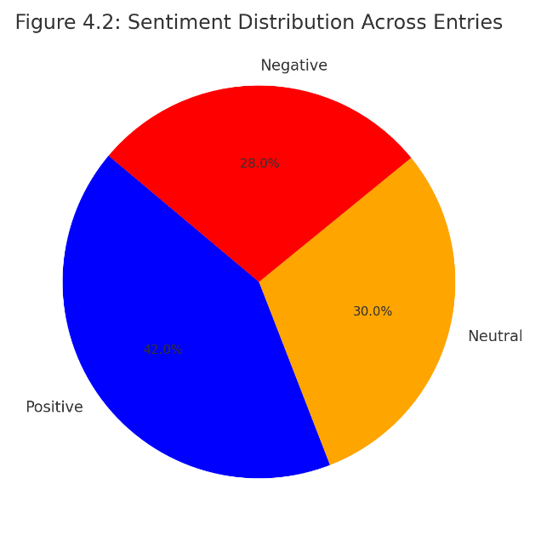

**Fig 6.1: Sentiment Distribution Across Entries**

In terms of **semantic memory retrieval**, LifeCapsule was evaluated using 50 user prompts. The relevance of retrieved memories was categorized into High, Moderate, and Low relevance, showcasing the system's accuracy in recalling emotionally aligned reflections. This is represented in **Table 7.1 – Assistant Query Evaluation Breakdown**, which clearly illustrates the distribution of relevance levels.

**Table 6.1 – Assistant Query Evaluation Breakdown**

|  |  |  |
| --- | --- | --- |
| **Relevance Level** | **Count** | **Percentage** |
| High | 38 | 76% |
| Moderate | 9 | 38% |
| Low | 3 | 6% |

The evaluation also covered system performance in terms of response times for different query types. LifeCapsule demonstrated efficiency in handling reflective queries with minimal latency. The average response times for three primary query types are represented in Table 7.2 – Response Time by Query Type

**Table 6.2 – Response Time by Query Type**

|  |  |
| --- | --- |
| **Query Type** | **Avg. Response Time (s)** |
| Simple Recall | 1.2 |
| Emotional Context | 2.3 |
| Summary generation | 3.1 |

In addition to sentiment analysis and memory retrieval, LifeCapsule's capabilities were further evaluated through emotional trend tracking. To assess the accuracy and reliability of sentiment analysis, 100 synthetic diary entries were created with predefined emotional biases—categorized as positive, neutral, or negative sentiments. These entries were processed by TextBlob to analyze the polarity of each entry over a structured two-week period. The results were visualized in Figure 7.2: Sentiment Polarity over Time, showcasing the emotional fluctuations detected by LifeCapsule.

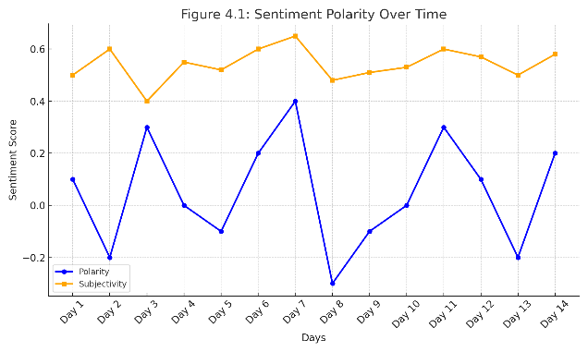

**Fig 6.2: Sentiment Polarity Over Time**

**CHAPTER 7**

**CONCLUSION AND FUTURE ENHANCEMENTS**

LifeCapsule represents a significant advancement in the domain of digital journaling and memory management. By leveraging state-of-the-art technologies such as **LangChain**, **Chroma**, **LLaMA 3.2**, and **TextBlob**, it delivers an emotionally aware and contextually intelligent journaling experience. Unlike traditional journaling applications that merely store textual entries, LifeCapsule provides users with meaningful reflections and emotional insights, allowing them to observe patterns in their mental well-being and recall specific memories with semantic accuracy. Its local-first architecture ensures that all data processing, sentiment analysis, and memory retrieval occur entirely on the user’s device, safeguarding privacy and data sovereignty. This approach distinguishes LifeCapsule as a pioneering tool that respects user privacy while delivering emotionally intelligent interactions.

The system's capabilities extend beyond mere reflection; it also includes **health cue detection**, which analyzes linguistic patterns for signs of fatigue, anxiety, or depressive tendencies. Although not diagnostic, these indicators help users recognize potential health concerns early, fostering better self-awareness and proactive well-being management. LifeCapsule's performance, as demonstrated through evaluation, showcases high semantic relevance in memory retrieval, rapid response times, and effective sentiment tracking—all contributing to a seamless and responsive user experience.

Moving forward, LifeCapsule is well-positioned for several **future enhancements**. One key area of development is the integration of **voice-based journaling**, allowing users to record their reflections verbally, which would be transcribed and analyzed in real-time. This would make journaling more natural and accessible, particularly during hands-free scenarios. Another potential upgrade is the incorporation of **biometric data** from wearable devices, such as smartwatches, to correlate physical health metrics with emotional states. This integration could provide users with a deeper understanding of how physiological changes impact their mental well-being.

Additionally, the implementation of **predictive mood analysis** could enable LifeCapsule to forecast emotional states based on historical data, empowering users to anticipate and manage emotional shifts proactively. Finally, expanding to **multi-platform synchronization** would allow seamless access to LifeCapsule across multiple devices while maintaining its commitment to privacy and security. These enhancements not only extend the application’s utility but also reinforce its mission to support emotional health and memory preservation in a secure, user-centered manner.

**CHAPTER 8**

**REFERENCES**

**[**1] Hoffmann, J., Borgeaud, S., Mensch, A., et al. “Training Compute-Optimal Large Language Models,” *DeepMind*, 2023.

[2] Borgeaud, S., Mensch, A., Hoffmann, J., et al. “Improving Language Models by Retrieving from Trillions of Tokens,” *arXiv preprint arXiv:2112.04426*, 2021.

[3] Vaswani, A., Shazeer, N., Parmar, N., et al. “Attention is All You Need,” *Advances in Neural Information Processing Systems*, 2017.

[4] Radford, A., Narasimhan, K., Salimans, T., & Sutskever, I. “Improving Language Understanding by Generative Pre-Training,” *OpenAI*, 2018.

[5] Goyal, N., Fedus, W., Zoph, B., et al. “Scaling Transformers via Sparse Expert Models,” *arXiv preprint arXiv:2106.04560*, 2021.

[6] Kwiatkowski, T., Palomaki, J., Redfield, O., et al. “Natural Questions: A Benchmark for Question Answering Research,” *Transactions of the Association for Computational Linguistics*, 2019.

[7] Kudo, T., & Richardson, J. “SentencePiece: A Simple and Language Independent Subword Tokenizer and Detokenizer for Neural Text Processing,” *Proceedings of EMNLP: System Demonstrations*, 2018.

[8] Lin, C.-H., & Chen, Y.-Y. “HyperQUEEN: Hyperspectral Quantum Deep Network for Image Restoration,” *IEEE Transactions on Geoscience and Remote Sensing*, vol. 61, 2023.

[9] Parthasarathy, R., & Bhowmik, R. T. “Quantum Optical Convolutional Neural Network: A Novel Image Recognition Framework for Quantum Computing,” *IEEE Access*, vol. 9, pp. 103337–103346, 2021.

[10] L’Abbate, R., et al. “A Quantum-Classical Collaborative Training Architecture Based on Quantum State Fidelity,” *IEEE Transactions on Quantum Engineering*, vol. 5, 2024.

[11] Yousif, M., Al-Khateeb, B., & Garcia-Zapirain, B. “A New Quantum Circuits of Quantum Convolutional Neural Network for X-Ray Images Classification,” *IEEE Access*, vol. 12, pp. 65660–65671, 2024.

[12] Andrés, E., Cuéllar, M. P., & Navarro, G. “Efficient Dimensionality Reduction Strategies for Quantum Reinforcement Learning,” *IEEE Access*, vol. 11, pp. 104534–104553, 2023.

[13] Yan, R., Wang, Y., Xu, Y., & Dai, J. “A Multiagent Quantum Deep Reinforcement Learning Method for Distributed Frequency Control of Islanded Microgrids,” *IEEE Transactions on Control of Network Systems*, vol. 9, no. 4, pp. 1622–1632, Dec. 2022.

**CHAPTER 9**

**APPENDIX**

**APPENDIX – I**

**APPENDIX – II**

**SOURCE CODE**

from flask import Flask, request, jsonify

from flask_cors import CORS

from langchain.prompts import PromptTemplate

from langchain_ollama import OllamaLLM, OllamaEmbeddings

from langchain_community.vectorstores import Chroma

from langchain.text_splitter import RecursiveCharacterTextSplitter

from langchain.chains import RetrievalQA

from textblob import TextBlob

import os

from datetime import datetime

# Flask app setup

app = Flask(__name__)

CORS(app)

# Constants

DIARY_FILE_PATH = "./diary.txt"

CHROMA_DB_DIR = "./chroma_db"

# Global Variables

vectorstore = None

qa_chain = None

# Initialize the Ollama model

ollama_llm = OllamaLLM(model="llama3.2", streaming=False)

# Initialize Embeddings

embeddings = OllamaEmbeddings(model="llama3.2")

# Initialize Text Splitter

text_splitter = RecursiveCharacterTextSplitter(chunk_size=1000, chunk_overlap=200)

# Function to load diary entries

def load_diary_entries(file_path):

    try:

        if os.path.exists(file_path):

            with open(file_path, 'r') as file:

                return file.read()

        return ""

    except Exception as e:

        print(f"Error loading diary entries: {e}")

        return ""

# Function to save diary entry

def save_diary_entry(file_path, entry):

    try:

        timestamp = datetime.now().strftime("%B %d, %Y")

        formatted_entry = f"{timestamp}:\n{entry.strip()}\n\n"

        with open(file_path, 'a') as file:

            file.write(formatted_entry)

    except Exception as e:

        print(f"Error saving diary entry: {e}")

# Perform sentiment analysis

def analyze_sentiment(text):

    try:

        blob = TextBlob(text)

        return blob.sentiment.polarity

    except Exception as e:

        print(f"Error analyzing sentiment: {e}")

        return 0

# Check if question is relevant

def is_relevant_question(query):

    keywords = ['feel', 'felt', 'emotion', 'happy', 'sad', 'angry', 'mood', 'health', 'symptom', 'day', 'diary', 'entry']

    return any(keyword in query.lower() for keyword in keywords)

# Update the knowledge base

def update_knowledge_base():

    global vectorstore, qa_chain

    diary_content = load_diary_entries(DIARY_FILE_PATH)

    if diary_content.strip():

        split_texts = text_splitter.split_text(diary_content)

        vectorstore = Chroma.from_texts(

            texts=split_texts,

            embedding=embeddings,

            persist_directory=CHROMA_DB_DIR

        )

        vectorstore.persist()

        prompt_template = PromptTemplate(

            input_variables=["context", "question"],

            template="""You are a helpful assistant that strictly analyzes diary entries and answers ONLY if the answer is clearly present.

If the diary does not contain enough information to answer the question, say:

\"I don’t know based on the diary entries.\"

Context from diary:

{context}

Question: {question}

Answer:"""

        )

        qa_chain = RetrievalQA.from_chain_type(

            llm=ollama_llm,

            retriever=vectorstore.as_retriever(),

            return_source_documents=False,

            chain_type_kwargs={"prompt": prompt_template}

        )

        print("Knowledge base updated.")

    else:

        vectorstore = None

        qa_chain = None

        print("No entries found in the diary. Knowledge base is empty.")

# Process a user query using the Ollama model

def process_prompt_with_model(prompt):

    prompt_template = PromptTemplate(

        input_variables=["user_input"],

        template="{user_input}"

    )

    formatted_prompt = prompt_template.format(user_input=prompt)

    try:

        result = ollama_llm.invoke(formatted_prompt)

        return result

    except Exception as e:

        print(f"Error invoking Ollama model: {e}")

        return "I encountered an error while processing your request. Please try again."

# Analyze the diary

def analyze_diary(query):

    if not query.strip():

        return "Please provide a valid question."

    if not is_relevant_question(query):

        return "Sorry, I can only answer questions based on your diary entries."

    if not qa_chain:

        return "The knowledge base is empty. Please add diary entries first."

    try:

        diary_content = load_diary_entries(DIARY_FILE_PATH)

        entries = diary_content.split("\n\n")

        if "happy" in query.lower() or "joy" in query.lower():

            positive_entries = [

                entry for entry in entries if analyze_sentiment(entry) > 0.5

            ]

            if positive_entries:

                return f"You seemed happy or joyful on the following days:\n{chr(10).join(positive_entries)}"

            else:

                return "I couldn't find any clear indications of happiness in your diary."

        elif "sad" in query.lower() or "down" in query.lower():

            negative_entries = [

                entry for entry in entries if analyze_sentiment(entry) < -0.5

            ]

            if negative_entries:

                return f"You seemed sad or down on the following days:\n{chr(10).join(negative_entries)}"

            else:

                return "I couldn't find any clear indications of sadness in your diary."

        elif "angry" in query.lower() or "frustrated" in query.lower():

            angry_entries = [

                entry for entry in entries if -0.5 <= analyze_sentiment(entry) < 0

            ]

            if angry_entries:

                return f"You seemed angry or frustrated on the following days:\n{chr(10).join(angry_entries)}"

            else:

                return "I couldn't find any clear indications of anger in your diary."

        elif "calm" in query.lower() or "peaceful" in query.lower():

            calm_entries = [

                entry for entry in entries if 0 <= analyze_sentiment(entry) <= 0.5

            ]

            if calm_entries:

                return f"You seemed calm or peaceful on the following days:\n{chr(10).join(calm_entries)}"

            else:

                return "I couldn't find any clear indications of calmness in your diary."

        result = qa_chain.run(query)

        return result or "I don’t know based on the diary entries."

    except Exception as e:

        print(f"Error analyzing diary: {e}")

        return "Something went wrong while analyzing your diary. Please try again later."

# Initialize the knowledge base on server start

update_knowledge_base()

@app.route('/save_diary', methods=['POST'])

def save_diary():

    data = request.json

    entry = data.get('entry', '').strip()

    if entry:

        save_diary_entry(DIARY_FILE_PATH, entry)

        update_knowledge_base()

        return jsonify({"status": "success", "message": "Your diary entry has been saved."}), 200

    return jsonify({"status": "error", "message": "No entry provided."}), 400

@app.route('/analyze_diary', methods=['POST'])

def analyze_diary_endpoint():

    query = request.json.get('query', '').strip()

    if query:

        response = analyze_diary(query)

        return jsonify({"answer": response}), 200

    return jsonify({"status": "error", "message": "No query provided."}), 400

@app.route('/prompt_query', methods=['POST'])

def prompt_query():

    data = request.json

    prompt = data.get('prompt', '').strip()

    if prompt:

        response = process_prompt_with_model(prompt)

        return jsonify({"response": response}), 200

    return jsonify({"status": "error", "message": "No prompt provided."}), 400

@app.route('/health_check', methods=['GET'])

def health_check():

    return jsonify({"status": "ok", "model": ollama_llm.model}), 200

if __name__ == '__main__':

    app.run(debug=True)